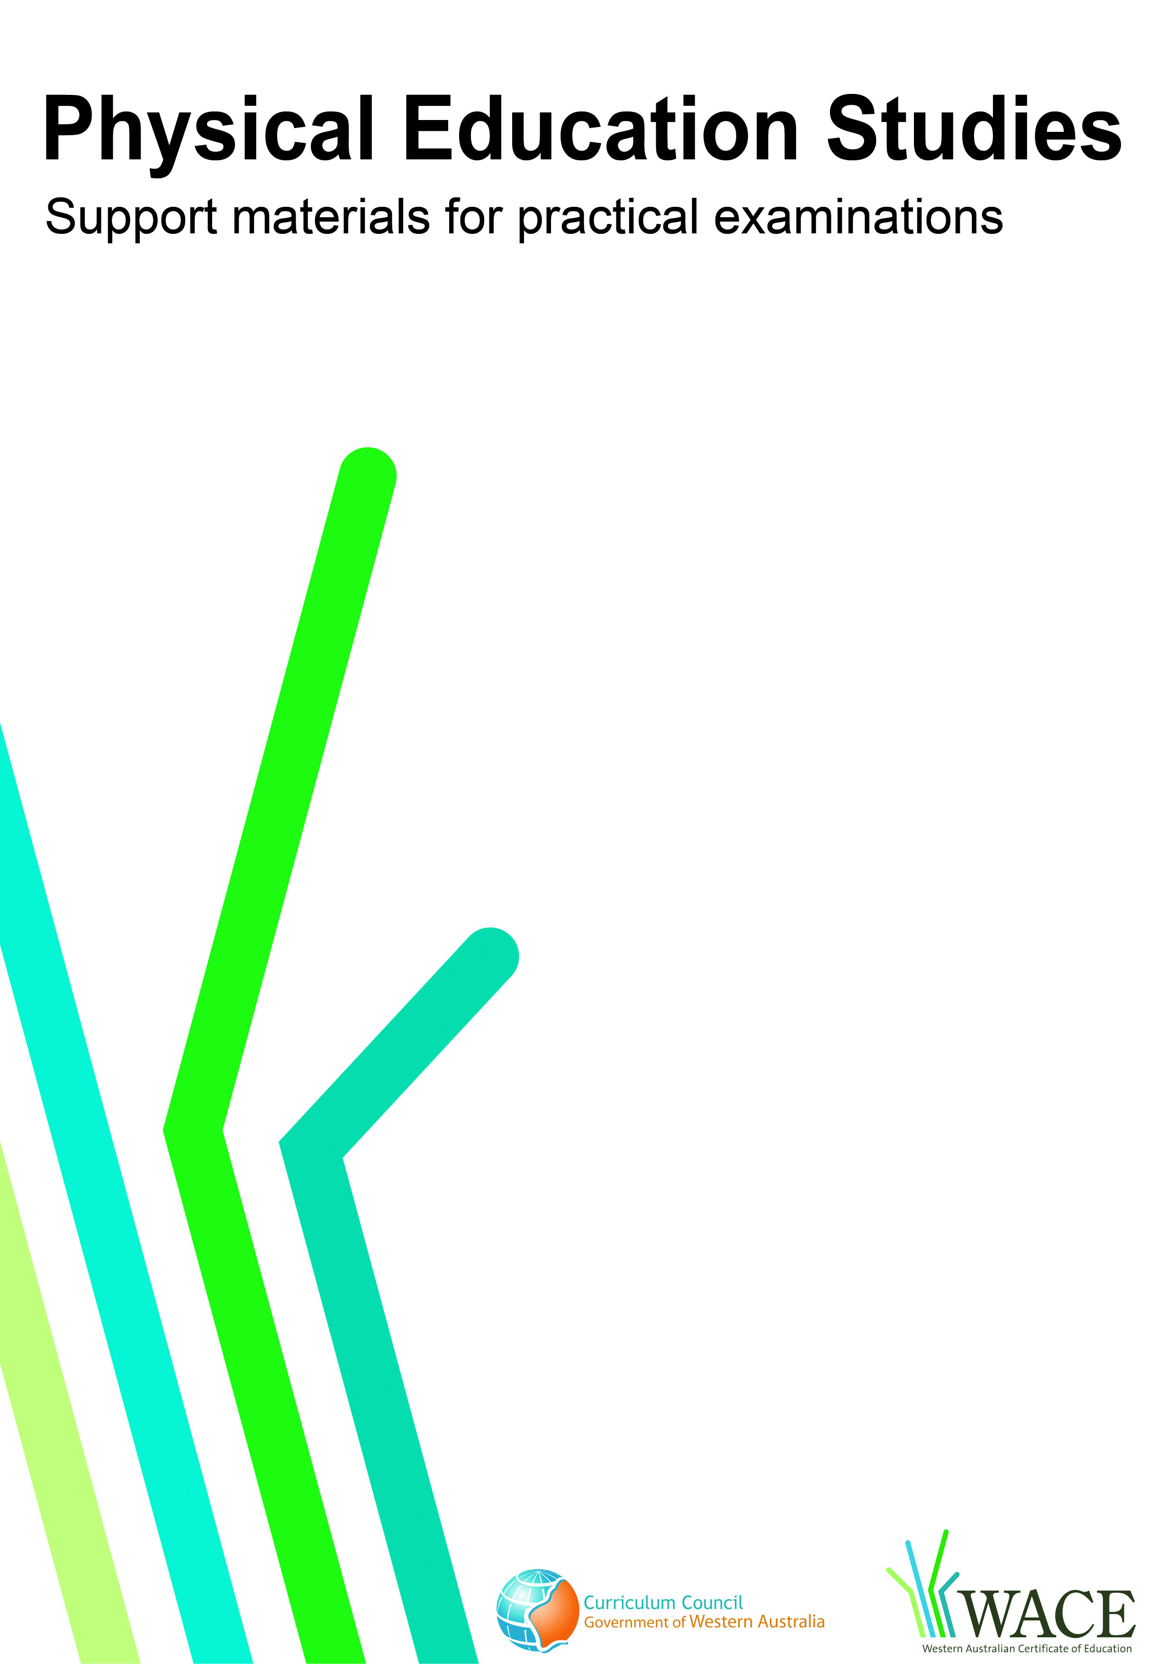

Hockey

© Curriculum Council, 2009
This document—apart from any third party copyright material contained in it—may be freely copied, or communicated on an intranet, for non-commercial purposes by educational institutions, provided that it is not changed in any way and that the Curriculum Council is acknowledged as the copyright owner.
Copying or communication for any other purpose can be done only within the terms of the Copyright Act or by permission of the Curriculum Council.
Copying or communication of any third party copyright material contained in this document can be done only within the terms of the Copyright Act or by permission of the copyright owners.
Version 3

© Curriculum Council, 2011
This document—apart from any third party copyright material contained in it—may be freely copied, or communicated on an intranet, for non-commercial purposes by educational institutions, provided that it is not changed in any way and that the Curriculum Council is acknowledged as the copyright owner.
Copying or communication for any other purpose can be done only within the terms of the Copyright Act or by permission of the Curriculum Council.
Copying or communication of any third party copyright material contained in this document can be done only within the terms of the Copyright Act or by permission of the copyright owners.
Version 5

Introduction
The purpose of these materials is to support teachers and candidates in preparation for the Physical Education Studies practical examination.

Skills set for hockey
These materials outline the examinable skills set for Hockey. Five (5) of the skills, selected by the examination panel, will be examined and these will be communicated to the candidates at the commencement of the examination.

Observation points
Observation points are provided for each skill in the skills set. They are provided for the purpose of teaching and coaching and are designed to assist examination candidates in their personal skill development.

Examination drills
The examination will contain a number of drills through which the selected skills will be assessed. These materials outline a number of drills indicative of the types of drills in which the candidates will participate during the examination and may form part of a teaching program.

Tactical framework
In the conditioned performance section of the examination, candidates will participate in a modified competitive situation, which will be based on some of the tactical problems in hockey. The tactical problems for the examination are outlined in the tactical framework and will be selected by the examination panel. The skills that provide the basis for the solutions to these tactical problems are also included in the framework.

In the conditioned performance section of the hockey examination, students will be assessed on the execution of skills, use of space, positioning and decision making that effectively solve the tactical problems presented by the modified competitive situation.

Specialist skills
Contained within this document are a number of skills that have been identified as having a degree of specialisation. They are skills that some students may choose to focus on. These skills are included within this document as they may form part of a teaching program; however, they will not be included in the Physical Education Studies practical examination.

CONTENTS | PAGE NUMBER
Hockey skills set | 5
Skills set and observation points | 6
Hockey drills | 11
Drill descriptions | 13
Tactical framework | 27

Skill number | Name of skill | Page number
1 | Hit | 6
2 | Push | 6
3 | Slap hit | 6
4 | Flick (Overhead) | 7
5 | Trap – Flat stick and Reverse stick | 7
6 | Flat Stick dribble | 7
7 | Indian dribble | 8
8 | Drag to eliminate | 8
9 | Flat and reverse stick tackle | 8
10 | Jab tackle | 9
11 | Mark to intercept; marking to defend/dispossess | 9
12 | Specialist skills: Goalkeeping – positioning and the attacking stance (not examined externally) | 9
13 | Specialist skills: Goalkeeping – the instep jab kick (not examined externally) | 10
14 | Specialist skills: Goalkeeping – aerial saves  (not examined externally) | 10

1. HIT
Preparation | Execution | Completion
- Hands together with wrists cocked  - Body side on to target  - Front foot aligned with ball at strike point  - Eyes looking at the ball | - Controlled backswing  - Weight transfer from back to flexed front leg during swing  - Balanced at strike with left foot placed at 45° to the direction of the pass and in line with the ball  - Left knee slightly bent for low body position and generate power  - Elbow leads the down swing  - Elbows extend (unfold) on downswing to allow stick to come into contact with the ball  - Strong wrist action causing the stick head to accelerate  - Nose over the impact point of the ball | - Stick controlled during follow through and in the direction of the pass  - Timing – stick contact square to the ball  - Trajectory of the ball is flat and matches the intended speed and direction
2. PUSH
Preparation | Execution | Completion
- Body side on with left shoulder to the target  - Knees are flexed  - Weight balanced towards the back foot  - Hands shoulder width apart with left hand at the top of the stick | - Face of stick on or near the ball facing the target  - Ball positioned away from feet in line with the eyes  - The right arm pushes the ball towards the target keeping the stick along the ground  - Weight transfer to flexed front leg | - Stick remains low and towards the target on follow through (“point to the target”)  - Trajectory of the ball is flat and matches the intended speed and direction
3. SLAP HIT
Preparation | Execution | Completion
- Body is side on, left shoulder to the target  - Feet slightly wider than shoulder width apart  - Knees flexed, weight balanced on back foot  - Bottom hand positioned low, approximately at the end of the grip | - Stick on the ground away from the ball  - Ball is positioned well away from feet in line with front foot  - Transfer weight onto front foot  - Rotation of upper torso to slap through the ball  - The ball contacts the shaft of the stick approximately 10-15cm from the head | - Stick completes a low sweep close to the ground contacting the ball mid-shaft  - Stick and ball contact perpendicular to the target for accuracy  - Trajectory of the ball is flat and matches the intended speed and direction

4. FLICK (OVERHEAD)
Preparation | Execution | Completion
- Body side on, left shoulder to the target  - Feet slightly wider than shoulder width apart  - Knees flexed, weight balanced on back foot  - Hands apart, stick positioned behind the ball tilted back at 45° angle | - Ball positioned closer to the left foot for control and power  - Eyes and head slightly behind the ball – torso leaning backward  - Stick angle dependent on required height  - With the right arm dominant, stick-head pushes under, through and up – pointing high towards desired flight path  - Transfer weight through torso and onto front foot simultaneously | - Stick follows the trajectory of the ball  - Height of the ball will be varied  - Trajectory of the ball follows the desired height and distance and clears the defender
5. TRAP – FLAT STICK AND REVERSE STICK
Preparation | Execution | Completion
- Strong, low body position, upper body straight  - Knees and hips are flexed  - Receive on 45° angle, left shoulder forward for flat stick trap (right shoulder forward for reverse stick trap)  - Hands apart on the stick, right hand lower – halfway down  - Feet wider than shoulder width  - Knees flexed | - Receive the ball on right side of the body (left side for reverse stick trap)  - Stick turned over by rotating right hand for reverse stick trap  - Eyes track the ball to the stick  - Weight on front foot transferred to back foot upon reception  - Balanced and stable body position | - Stick gives with the ball to absorb impact  - Ball is trapped and controlled
1
6. FLAT STICK DRIBBLE
Preparation | Execution | Completion
- Strong, low body position, upper body straight  - Knees and hips are flexed  - Head down, eyes up  - Hands shoulder width apart on the stick | - Stick angled between 45º and 90º  - Ball remains in reach of the stick – able to control or regain control with ease  - Ball position ahead of feet and slightly to the right (at 1 o’clock)  - Maintains balance and posture whilst running | - Maintains control of the ball  - Timing – flat stick dribble is best utilised at pace to maximise space and vision

7. INDIAN DRIBBLE
Preparation | Execution | Completion
- Strong, low body position, upper body straight  - Head down, eyes up  - Hands shoulder width apart on the stick  - Top hand rotates, bottom hand loose, cradling stick. Bottom hand can also rotate | - Ball in front of the body so as it can be dragged left to right (between 12 and 2 o’clock)  - Ball moves left to right and right to left and forward relevant to pace  - Maintains balance and posture whilst running  - Stick turns over the ball  - Ball remains in reach of the stick – able to control or regain control with ease | - Able to maintain control of the ball at any stage  - Timing – fast enough to maintain control
8. DRAG TO ELIMINATE (indicated for R to L – need to reverse for L to R)
Preparation | Execution | Completion
- Hands shoulder width apart on stick  - Ball outside of right foot and in front  - Movement starts with weight on the right foot  - Stick faces to the left and contact with the ball | - Ball moves with one move in front of the feet until beyond left foot  - Angle of drag – varies backwards to avoid flat-stick and swinging tackles  - Weight transfers to the left foot  - Strong push off with left foot to accelerate past defender, taking the ball with you  - Ball repositioned to 12 o’clock (start position for next skill – pass, shoot etc) | - Direction of movement is adjusted to eliminate the defender from making a further tackle  - Positioning of drag to suit the situation (forwards or backwards)  - Defensive player is eliminated
9. FLAT AND REVERSE STICK TACKLE
Preparation | Execution | Completion
- Strong, low balanced position  - Left foot forward for flat stick and right foot forward for reverse stick tackle  - One foot behind the other, never square  - Hands apart on the stick, hovering slightly above ground  - Feet and stick make a strong triangle shaped base | - Stick head close to the ground  - Stick face angled towards the ball  - Lunge towards opponent in low position as ball momentarily leaves the attacker’s stick  - Position of the stick at the wrist: flat stick lunge to be at 3 o‘clock and reverse stick lunge to be at 9 o‘clock | - Return to upright positioning in preparation for next move and protect feet  - Opponent is dispossessed with opportunity to gain control of the ball

10. JAB TACKLE
Preparation |  | Execution |  | Completion
- Side on to ball carrier  - Appropriate foot forward to channel ball carrier  - Knees flexed and balanced  - Feet never square, always moving with weight on back foot able to move in all directions |  | - Stick head close to the ground  - Stick in front of the body and directed towards the ball  - At the jab, right hand releases the stick  - Left hand pokes the stick forward and towards the ball |  | - Stick retracts back to original stick position and ready for next action  - Good recovery position if missed  - Successful – push through and secure possession
 | 11. MARK TO INTERCEPT; MARKING TO DEFEND/DISPOSSESS
 | Preparation |  | Execution |  | Completion
 | - Maintain body balance  - Stick held in ready position to tackle  - Defender positioned between the attacker and the defensive goal (“back marking”)  - Defender positioned between the attacker and the ball (‘intercept marking’)  - Defender very close to attacker – to control and mirror movements |  | - Moves into position to make a tackle/intercept  - Covers space to make an interception or maintaining position to apply pressure to the player  - Eyes up tracking the play |  | - Intercept position –opponent unable to get possession  - Marking position –defender between opponent and the goal in a position to maintain pressure and win the ball  - Good markers can determine whether to be aggressive (intercept/in front) or be conservative (behind) – dictated by the quality of the passing and speed of opponent
 | 12. SPECIALIST SKILLS: GOALKEEPING – POSITIONING AND THE ATTACKING STANCE (not examined externally)
 | Preparation |  | Execution |  | Completion
 | - The goalkeeper is positioned on their ‘invisible semi circle’ that runs from post to post  - The goalkeeper is in the correct line in order to save the shot at goal – this means they have assessed the angle of the ball to the goal and they are positioned on the right line  - The goalkeeper is in the attacking stance, legs slightly apart, up on the balls of their feet, knees bent, slight bent at waist, head and body weight forward, hand up around chest height – fingers pointing up, stick and glove also up around chest/shoulder height in anticipation for the shot |  | - The goalkeeper quickly moves to the correct position on their ‘invisible semi circle’  - The goalkeeper immediately assumes the attacking stance and is ready for the shot |  | - The goalkeeper has successfully positioned themselves to make the save  - On making the save they immediately reposition back into the attacking stance ready to clear or save any rebounds that may come their way

13. SPECIALIST SKILLS : GOALKEEPING – THE INSTEP JAB KICK (not examined externally)
Preparation |  | Execution |  | Completion
- The goalkeeper is in the correct position (on the right line) on their ‘invisible semi circle’ and has assumed the attacking stance ready to save the shot at goal |  | - The goalkeeper identifies which side of the body the ball is travelling towards  - The goalkeeper jabs the corresponding kicker out to the ball, making contact on the middle of the instep of the kicker (if the ball is travelling to the right side of the goalkeeper, the instep of their right kicker should be used and vice versa  - At this point the goalkeeper’s body weight should be forward the head over the ball on contact  - The resulting rebound should be close to the ground towards the sideline or away from the striker towards a safe area |  | - On making the save, the goalkeeper immediately repositions back into the attacking stance ready to clear or save any rebounds
 | 14. SPECIALIST SKILLS : GOALKEEPING – AERIAL SAVES (not examined externally)
 | Preparation |  | Execution |  | Completion
 | - The goalkeeper is in the correct position (on the right line) on their ‘invisible semi circle’ and has assumed the attacking stance ready to save the shot at goal  - The goalkeeper identifies which side of the body the ball is travelling towards  - Assume the aerial shot is travelling to the goalkeeper’s left side. The goalkeeper should immediately identify the height and speed of the shot |  | - The goalkeeper’s left leg moves over into the line of flight of the ball, this will take the body weight and head over towards the ball  - The goalkeeper saves the aerial shot with the left glove –fingers pointing up or out towards the side (depending on the height of the shot), with the head and body weight as close as possible to the point of contact. However, if it is directed to the right side, the goalkeeper can save the shot with the stick whilst placing the left glove across the body and above the stick  - The rebound off the glove should be up and over the goal, played down and out to the side or down onto the ground and into a safe location The goalkeeper should be in control of the resulting rebound |  | - The rebound should be controlled or directed into a safe location whenever possible  - On making the save, the goalkeeper immediately repositions back into the attacking stance ready to clear or save any rebounds  - If the ball does drop in close to the goalkeeper, it is expected that they will move to the ball quickly and kick it way from the danger area in front of the goal

Skills 12, 13 & 14 sourced from: Partridge, K., 2008, Goalkeeping skills and drills, Perth, WA: Kathleen Partridge
www.kathleenpartridge.com

Drill number |  | Page number
1 | Hitting | 12
2 | Pushing | 13
3 | Slap hit | 14
4 | Trapping – (Flat stick and reverse stick) | 15
5 | Trapping – (Flat stick and reverse stick) | 16
6 | Dribbling – Flat stick and Indian dribble | 17
7 | Flick (overhead) | 18
8 | Hit/push, Specialist skills: Goalkeeping – instep jab kick (not examined externally) | 19
9 | Flick (overhead), Hit, Specialist skills: Goalkeeping –aerial save (not examined externally) | 20
10 | Flat stick dribble, hit, push, slap | 21
11 | Trapping – (Flat stick and Reverse stick), drag to eliminate, pushing | 22
12 | Flat stick dribble, drag to eliminate, hit/push/slap | 23
13 | Flat stick dribble/Indian dribble, jab tackle/flat and reverse stick tackle, pushing, marking to intercept, marking to defend/dispossess | 24
14 | Flat stick dribble, jab tackle, flat and reverse stick tackle | 25
15 | Flat stick dribble, push, hit/slap hit, Specialist skills: Goal keeping – Positioning and attacking stance (not examined externally) | 26

These drills are indicative of the types of drills in which the candidates will participate during the examination and may form part of a teaching program.

Drill 1: Hitting
A

C

B

5m
2m
20m
X

2m
2m
2m
20m
A

C

B

5m
2m
20m
X

2m
2m
2m
20m
O

O

Variation 3

Key
X = player | → = player movement
O = feeder | ----- = ball movement
= marker | = hitting box

Drill description
- Player hits one ball at a time.
- First hit must pass through A, the second through B, the third through C.
- The player then performs the skill in the opposite direction through C, then through B then through A.
- This pattern is repeated.
Variations
- Player open dribbles from 5m behind the box then executes the skill.
- Player Indian dribbles through three cones, 5m behind the box, then executes the skill.
- Player receives a pass from a feeder three times from the left, then three times from the right:
- From the left – once to A, then once to B, then once to C
- From the right – once to A, then once to B, then once to C

Drill 2: Pushing
A

C

B

5m
2m
20m
X

2m
2m
2m
20m
A

C

B

5m
2m
20m
X

2m
2m
2m
20m
O

O

Variation 3

Key
X = player | → = player movement
O = feeder | ----- = ball movement
= marker | = hitting box

Drill description
- Player pushes one ball at a time.
- First push must pass through A, the second through B, the third through C.
- The player then performs the skill in the opposite direction through C, then through B then through A.
- This pattern is repeated.

Variations
- Player flat stick dribbles from 5m behind the box, then executes the skill.
- Player Indian dribbles through three cones, 5m behind the box, then executes the skill.
- Player receives a pass from a feeder three times from the left, then three times from the right:
- From the left – once to A, then once to B, then once to C
- From the right - once to A, then once to B, then once to C

Drill 3: Slap hit

A

C

B

5m
2m
20m
X

2m
2m
2m
20m
A

C

B

5m
2m
20m
X

2m
2m
2m
20m
O

O

Variation 3

Key
X = player | → = player movement
O = feeder | ----- = ball movement
= marker | = hitting box

Drill description
- Player slap hits one ball at a time.
- First hit must pass through A, the second through B, the third through C.
- The player then performs the skill in the opposite direction through C, then through B then through A.
- This pattern is repeated.

Variations
- Player flat stick dribbles from 5m behind the box then executes the skill.
- Player Indian dribbles through three cones, 5m behind the box, then executes the skill.
- Player receives a pass from a feeder three times from the left then three times from the right:
- From the left – once to A, then once to B, then once to C
- From the right – once to A, then once to B, then once to C

Drill 4: Trapping – (Flat stick and Reverse stick)
Diagram 1
Diagram 2

O

7 yds
2m
X

O

7 yds
2m
X

A
B
C
5m
5m

Key
X = player | → = player movement
O = feeder | ----- = ball movement
= marker | = hitting box

Drill description (diagram 1)
- Ball pushed at X (who is facing the feeder) from a distance of 7 yds. X must make a trap & maintain control of the ball without it going outside the 2m square area.
- Player to execute the skill with both the flat stick and reverse stick.
- Once the player controls the ball, he/she can pass it back to the feeder.

Variation (diagram 2)
- The ball is pushed to the player who will trap as per drill to gain control.
- The player will be required to turn and push the ball to either B or C.

Drill 5: Trapping – (Flat stick and Reverse stick)

Diagram 1
Diagram 2

O

16yds
3m
X

O

A

16yds

3m
X

B
C

5m
5m

Key
X = player | → = player movement
O = feeder | ----- = ball movement
= marker | = hitting box

Drill description (diagram 1)
- Ball is hit at X (who is facing the feeder) from a distance of 16yds. X must make a trap and maintain control of the ball without it going outside of the 3m square area.
- Player to execute the skill with both the flat stick and reverse stick.
- Once X controls the ball, he/she can pass it back to the feeder.

Variation (diagram 2)
- The ball is pushed to the player who will trap as per drill to gain control.
- The player will be required to turn and push the ball to either B or C.

Drill 6: Dribbling – Flat stick and Indian dribble

25 yard line

3m

D
2m
B

C
A
E

Half way line
START

Key
X = player | → = player movement
O = feeder | ----- = ball movement
= marker | = hitting box

Drill description
- Player starts at A and dribbles straight on flat stick to B.
- Player then follows the path B to C, using a flat stick dribble and a reverse stick where necessary to change the direction of the ball through the course.
- Player to negotiate path C to D using Indian dribble technique.
- Player must then complete the course by again carrying the ball flat stick from D to E and across the line.

Drill 7: Flick (Overhead)
3m
3m
5m

5m
Line A
Hockey
Goal
10m
X
7m
X
Goal
Goal
Diag 2
Diag. 1

Key
X = player | → = player movement
O = feeder | ----- = ball movement
= marker | = hitting box

Drill description (diagram 1)
- Player to flick balls from a stationary position from behind the line marked A.
- The ball must clear the hockey goal and travel directly over the top.
- Ball must drop in the 3m x 3m square on the full.

Variations
- The player executes a flick as per penalty stroke from the 7m spot. The player aims at the four areas (shaded) in the goal (diagram 2).
- Execute skill from backline of field to achieve maximum distance of ball flight.

Drill 8: Hit/push, Specialist skills: Goalkeeping – instep jab kick (not examined externally)
G
X₁
LEFT INSTEP
RIGHT INSTEP

Goal

Key
X = player | → = player movement
O = feeder | ----- = ball movement
= marker | = hitting box
G = goalkeeper

Drill description
- X₁ pushes or softly hits a ball onto the right kicker of the goal keeper.
- The goalkeeper performs an instep jab kick with the right kicker, clearing the ball out to the right side line.
- X₁ also pushes or softly hits a ball on the goalkeeper’s left kicker. The goalkeeper clears the ball with the left kicker.
- The goalkeeper must use the kicker that corresponds to the direction of the shot at goal; that is right side equals right instep, left side equals left instep.

Sourced from: Partridge, K., 2008, Goalkeeping skills and drills, Perth, WA: Kathleen Partridge
www.kathleenpartridge.com

Drill 9: Flick (overhead), Hit, Specialist skills: Goalkeeping – aerial save (not examined externally)
G
X₁

Goal

Key
X = player | → = player movement
O = feeder | ----- = ball movement
= marker | = hitting box
G = Goalkeeper

Drill description
- X₁ flicks or hits a ball to the goalkeeper’s right side.
- The goalkeeper attempts to save the ball with their left glove, firmly rebounding the ball down and out of the circle towards the sideline or over the backline.
- The goalkeeper should attempt to save some of these aerial shots just with the right glove and stick.

Sourced from: Partridge, K., 2008, Goalkeeping skills and drills, Perth, WA: Kathleen Partridge
www.kathleenpartridge.com

Drill 10: Flat stick dribble, hit, push, slap

Goal

20m
A
Hit

B
Hit

A

C

B

X

10m

Key
X = player | → = player movement
O = feeder | ----- = ball movement
= marker | = hitting box

Drill description
- Player starts at marker A and flat stick dribbles the ball around the marker B before hitting/slapping/pushing the ball at the target portable goal.
- Player continues after the hit to collect a second ball from A before hitting (flat stick) from C.

Drill 11: Trapping – (Flat stick and Reverse stick), drag to eliminate, pushing

X₂
X₃
3m
5m
5m
3m
X₁
X₄

Key
X = player | → = player movement
O = feeder | ----- = ball movement
= marker | = hitting box

Drill description
- X₁ to receive a push pass from X₂ and trap under control.
- X₁ drags the ball around X₄ and push passes the ball to X₃ (drag right to left and left to right).
- Ball should remain under control within the 3m square.

Drill 12: Flat stick dribble, drag to eliminate, hit/push/slap
2m

10m

F
3m
E
D

C
B
5m
5m

A

X₁

Key
X = player | → = player movement
O = feeder | ----- = ball movement
= marker | = hitting box

Drill description
- Player begins at A.
- Flat stick dribble towards marker B, drag left to right from marker B to C.
- Drag back left and dribble towards marker D, drag left to right from marker D to E.
- Drag around marker E and continue to F.
- Gain control after marker F and hit/push or slap ball (on the move if possible) through the 2m target gate.
- Drill to be performed at speed.

Variation
- This may be combined with drills 1–3.

Drill 13: Flat stick dribble/Indian dribble, jab tackle/flat and reverse stick tackle, pushing, marking to intercept, marking to defend/dispossess
GOAL C
2m
GOAL D
2m

X₂
5m

5m
X₃
X₁
X₄

2m
GOAL B
2m
GOAL A

Key
X = player | → = player movement
O = feeder | ----- = ball movement
= marker | = hitting box

Drill description
- X₁ and X₂ versus X₃ and X₄ (two on two).
- X₃ or X₄ initiates drill with pass on diagonal.
- X₃ and X₄ push up and attempt to win possession.
- X₁ and X₂ attempt to score through either goal A or B.
- If X₃ and X₄ win possession they will counter attack and attempt to score through goals C and D.
- Each team has six attacking opportunities before rotating. Attackers and defenders swap sides every three turns.
- Players rotate starting positions to ensure they have the opportunity to initiate play, attack and defend.

Drill 14: Flat stick dribble, jab tackle, flat and reverse stick tackle
B
C
E
D
2m
25m
2m
A
X₁
X₂

O

5m
7m

Key
X = player | → = player movement
O = feeder | ----- = ball movement
= marker | = hitting box

Drill description
  - Attacker X₁ must start at Marker A.
  - Defender X₂ must start at Marker C.
  - Ball starts with the feeder near X₂, who makes a strong pass out to X₁ to begin.
  - X₁ attempts to dribble the ball through markers D and E.
  - X₂ must push up to channel X₁, and engage to tackle and dispossess.
  - Either use sideline and channel left towards the backline closing the area that X₁ has to attack OR;
  - Get ball to the sideline and channel into a corner in preparation to dispossess.
  - Players swap after five attempts.

Drill 15: Flat stick dribble, push, hit/slap hit, Specialist skills: Goalkeeping – positioning and attacking stance (not examined externally)

Goal

G
G

Hit /
Slap hit

X₂
Push

X₁

Key
X = player | → = player movement
O = feeder | ----- = ball movement
= marker | = hitting box
G = goalkeeper

Drill description
  - Attacker X₁ starts with the ball.
  - Attacker X₂ waits on the opposite side at the top of the circle.
  - The goalkeeper positions themselves on the correct angle to attacker X₁ in the ready stance (goalkeeper is assuming attacker X₁ will have a shot at goal).
  - Attacker X₁ dribbles the ball into the circle and then pushes the ball to attacker X_{2.}
  - The goalkeeper repositions to be on the correct angle to the shot from attacker X_{2.}
  - The goalkeeper attempts to make a save.

Sourced from: Partridge, K., 2008, Goalkeeping skills and drills, Perth, WA: Kathleen Partridge
www.kathleenpartridge.com

Hockey tactical framework

Tactical problems | Off-the-ball skills | On-the-ball skills
OFFENCE
Maintaining possession | - Support play and off-ball positioning to be available  - Communication and cueing skills – informing ball carrier  - Maintaining awareness of the relative position of both team mates and opposition players to self | - Passing – short, long and aerial skills  - Receiving and ball control to maintain possession  - Receiving and ball control to eliminate opponent and gain numerical advantage
Creating and using space | - Maximise positioning (width and/or depth) to impact on opposition defence to create space for self and/or team mates  - Timing of lead to match ball carrier’s timing and defensive pattern  - Maintaining awareness of the relative position of both team mates and opposition players to self | - Optimal moment to release others  - Timing of pass/run to maximise space creation
Penetrating the defence | - Ability to create space for ball carriers  - Maintaining awareness of the relative position of both team mates and opposition players to self | - Ability to eliminate own and/or team mates’ defender with pass or skill
Attacking the goal | - Maintaining awareness of the relative position of both team mates and opposition players to self  - Positioning skills | - Utilising well-positioned strikers  - Receiving skills in congestion and under pressure  - Goal scoring mindset  - Shooting/finishing skills
Finishing the attack | - Communication – verbal  - Support play  - Rebounding after the goal shot | - Goal scoring mindset  - Shooting/finishing skills
TRANSITION PHASE
Attack to defence | - Recovery effort to reposition and minimise counter-attack damage (delay, channel, break down play) | - Mindset change  - Decision making – conservative delay vs. being aggressive and possibly eliminated
Defence to attack | - Recovery effort to reposition and maximise counter attacking opportunity against an exposed defence  - Mindset change | - Mindset change  - Decision making – when to attack versus when to hold possession and build sustained attacking pressure

Hockey tactical framework

DEFENCE
Defending space | - Marking opposition in front and behind, pressuring, keeping head down, delaying, covering, making recovery positioning.  - Body positioning low, mobile and stay alert | - Clearing the ball while maintaining possession
Defending the goal circle | - Goalkeeping – positioning and calling  - Defensive circle positioning and structure  - Denying direct access to goal  - Body positioning low, mobile and stay alert to cover attackers and protect feet | - Goalkeeping – saving the ball, shot stopping, clearances  - Tackling to protect feet and rule infringements
Goalkeeping  (NOT examined externally) | - Off-ball awareness (preparation and awareness) of possible threats  - Communication – defensive organisation  - Positioning | - Glove saves – left and right  - Foot and pad saves – left and right  - Stick saves and use  - Clearances using all four limbs
Defensive (winning the ball) skills | - Preparatory positioning to maintain pro-activeness (intercepts)  - Goal side positioning  - Recovery positioning (reactive) | - Tackling on both sides of the body – Flat stick and Reverse stick – block, poke (jab)  - Interception skills (trapping)  - Decision making – when to commit and when to hold up attack  - Channelling opposition team and individuals to plan
SET PLAYS
Penalty corner – attack | - Rebounding positioning after direct shot  - Body language to “sell” variations | - Push Out  - Trap  - Specialist Skills (PC Goal Scoring) – Drag Flick, Hit, Deflections, Variations  - Mental skills to eliminate distractions/pressure
Penalty corner defence | - Defensive role – first runner, post sweeper or second runner  - Rebounding positioning after direct shot to eliminate any subsequent shot | - Pressuring shooter  - Trapping the shot  - Pressure the variations/deflections.  - Mental skills to eliminate distractions/pressure
Penalty stroke attacking and defending | - Goalkeeping skills  - Goalkeeping strategies to increase pressure | - Flicking ability and skills  - Accuracy – high and low corners  - Mental skills to eliminate distractions/pressure

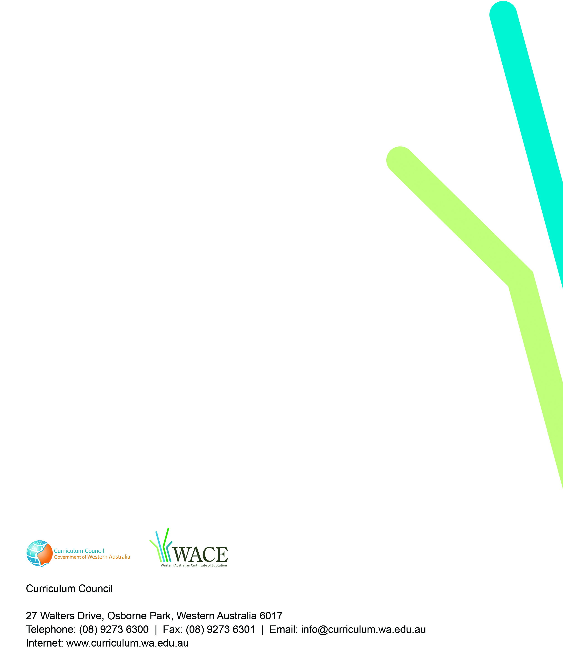
TRIM: 2009/8135[v4]

